Creating a Dichotomous Key
Name
Institution of Affiliation
Course Code
Date
Creating a Dichotomous Key

Key to Identifying Cats Go To:
Step 1 | 1a. Spots or stripes on skin | 2
Step 1 | 1b. plain skin | 3
Step 2 | 2a. Spots | 4
Step 2 | 2b. Stripes | Tiger
Step 3 | 3a. reddish skin | Lion
Step 3 | 3b. silvery skin | Cougar
Step 4 | 4a. Large | Jaguar
Step 4 | 4b. Small | 5
Step 5 | 5a. short tail | Canada lynx
Step 5 | 5b. long tail | ocelot

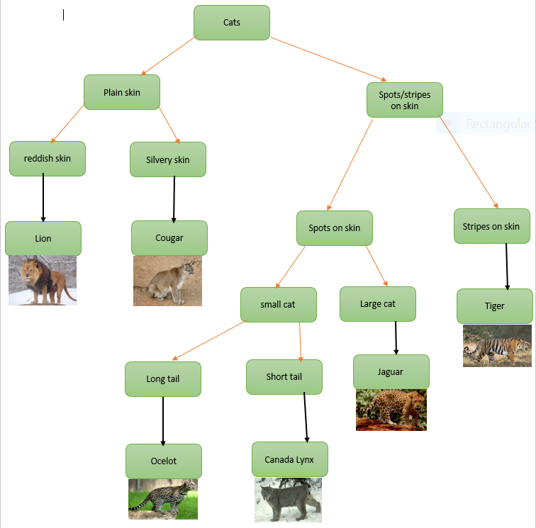

Canada Lynx
Short tail
Spots on skin
Silvery skin
Cougar
Ocelot
Long tail
Jaguar
small cat
Large cat
Tiger
Stripes on skin
Lion
reddish skin

